**Experiment 1.2**

**Student Name: Yash Gupta UID: 20BCS5009**

**Branch: BE-CSE Section/Group:20BCS_DM-716 B**

**Semester: 6 Date of Performance: 20/02/23**

**Subject Name: CC LAB Subject Code: 20CSP_351**

## Aim:

To implement the concept of string matching.

## Objective:

* + The objective is to build problem solving capability and to learn the basic concepts of data structures.
  + The implementation of Rotate String which shows and brushes up the concept of arrays.
  + The implementation of removing the duplicity in the Sorted-List-II.

## LeetCode code and output:

* **Rotating String**

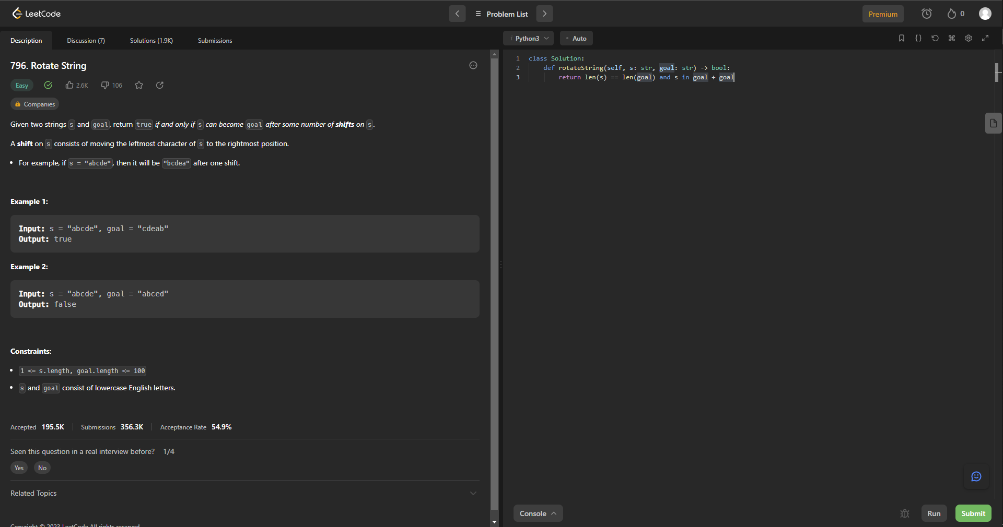

class Solution:

    def rotateString(self, s: str, goal: str) -> bool:

        return len(s) == len(goal) and s in goal + goal

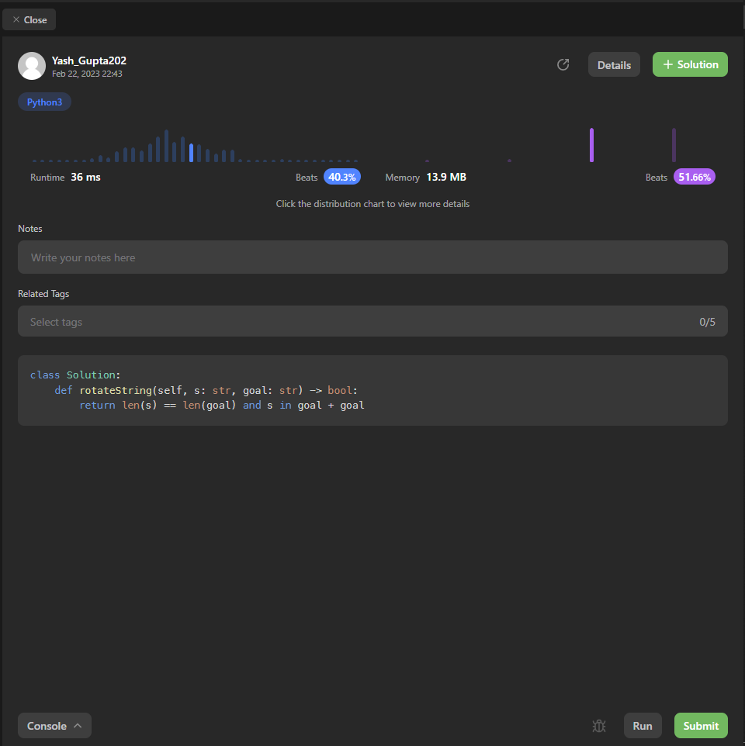

* **Find the Index of the First Occurrence in a String**

class Solution:

    def strStr(self, haystack: str, needle: str) -> int:

        for i in range(len(haystack)-len(needle)+1):

            if haystack[i:i+len(needle)]==needle:

                return i

        return -1

